SUPPLEMENTAL INFORMATION

Monetary reward magnitude effects on behavior and brain function during goal-directed behavior.

Rosell-Negre Pª, Bustamante JC^{b}, Fuentes Pª, Costumero Vª, Barrós Loscertales Aª*

ADDITIONAL RESULTS AND DISCUSSION

Functional task-related effects (Stroop-blocks > baseline)

As we describe in the main manuscript, we observed task-related effects (Stroop-blocks > baseline) throughout the frontal, parietal and striatal regions (see Table S1), which included: left insula, right precentral gyrus, bilateral superior frontal lobule, bilateral superior parietal lobule, left postcentral gyrus, left inferior parietal lobule, left supramarginal cortex, left supplementary motor area (SMA)/midcingulate and right caudate (p<0.001, FWE cluster-corrected).

Fig S1. Brain region showing task-related effects (Stroop-blocks > baseline) across monetary conditions.
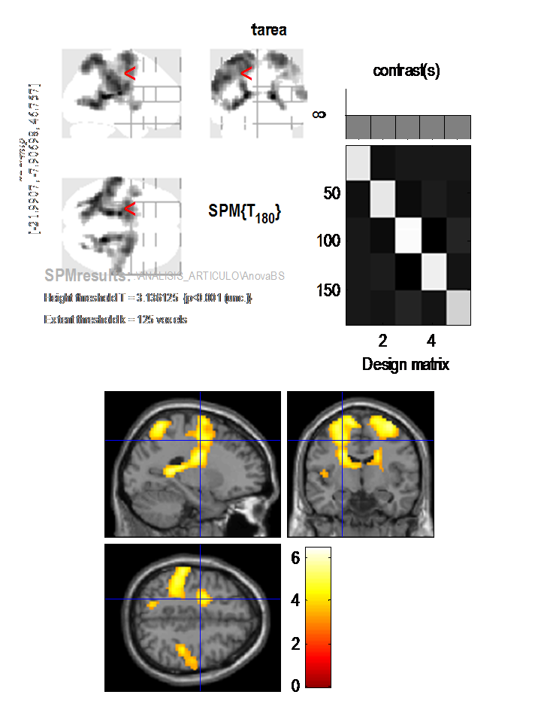

Table S1. Counting-Stroop related functional activations across monetary conditions.
 | Brain region | MNIª coordinates |  |  | Volume (mm³) | Z score
Stroop effect  (p<0.001, FWE cluster-corrected) | Left insula | -2 | 2 | -2 | 3375 | 4.64
Stroop effect  (p<0.001, FWE cluster-corrected) | Right precentral gyrus | 36 | -7 | 64 | ^{b} | 5.29
Stroop effect  (p<0.001, FWE cluster-corrected) | Right superior frontal lobule | 33 | -4 | 61 | ^{b} | 5.26
Stroop effect  (p<0.001, FWE cluster-corrected) | Left superior frontal lobule | -7 | -7 | 61 | ^{b} | 4.97
Stroop effect  (p<0.001, FWE cluster-corrected) | Right superior parietal lobule | 24 | -52 | 70 | 3618 | 4.59
Stroop effect  (p<0.001, FWE cluster-corrected) | Left superior parietal lobule | -27 | -55 | 67 | ^{b} | 5.52
Stroop effect  (p<0.001, FWE cluster-corrected) | Left postcentral gyrus | -63 | -19 | 25 | ^{b} | 5.57
Stroop effect  (p<0.001, FWE cluster-corrected) | Left inferior parietal lobule | -45 | -34 | 40 | ^{b} | 5.46
Stroop effect  (p<0.001, FWE cluster-corrected) | Left Supramarginal gyrus | -60 | -28 | 34 | ^{b} | 5.37
Stroop effect  (p<0.001, FWE cluster-corrected) | Left Supplementary Motor Area | -12 | -7 | 70 | ^{b} | 5.14
Stroop effect  (p<0.001, FWE cluster-corrected) | Right caudate | 18 | -19 | 19 | ^{b} | 5.37
a, dorsolateral prefrontal cortex; b, Brain regions included inside the main clusters; c, Montreal Neurologic Institute

